|  |
| --- |
|  |
| Brewers Buddy |
|  |
| User’s Manual |

**SWENG 500**

[Pick the date]

Authored by: Team 3

Table of Contents

Introduction 1

Getting Started 1

First Time Access to Brewer Buddy 1

Login to the Site 2

Update Profile 3

Logout 3

Managing Your Batches 4

# Introduction

The Most dynamic beer culture in the world is here. There is more going on with brewing in America than anywhere else.

Kalamazoo Brewing founder Larry Bell

Need some intro about how great and popular home brewing is

You can’t be a real country unless you have a beer and an airline – it helps if you have some kind of a football team, or some nuclear weapons, but at the very least you need a beer.

Frank Zappa

# Getting Started

## First Time Access to Brewer Buddy

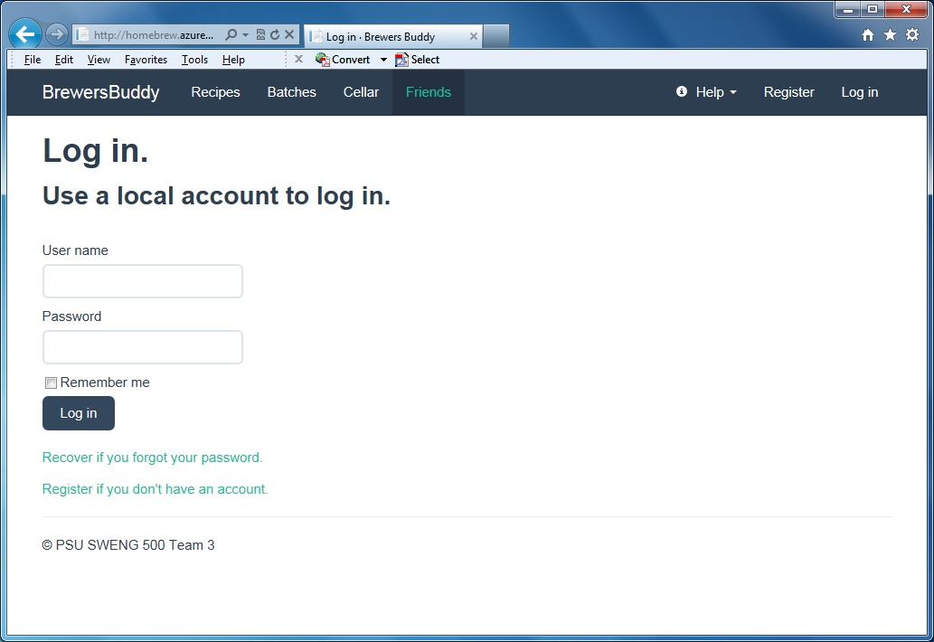

**Figure 1. Login Screen**

The Login screen will be the first page displayed when navigating to the Brewer Buddy online site. A brewer will need to login before they can enter the site. If this is the first time you are using Brewer Buddy, you will need to register as a new brewer. Selecting the Register link in the upper right hand corner of the Login Page will display the Registration form.

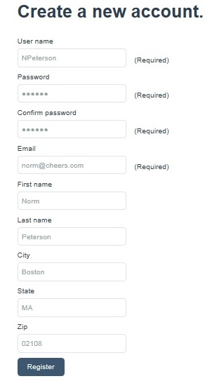The required information to register is a user name, password, and your email address. Two brewers cannot use the same user name or email address. If another brewer is already registered with that user name or email address, you will need to use a different one. The email address will be used to send you important information about your account. It is also required to reset your password if you forget it.

You may also enter your name and address. Your name and zip code may be used by other brewers to add you as a Friend and share batch information. Friends will be described in a later section.

**Figure 2. Registration Form**

When you have finished entering the registration information, select the Register button at the bottom of the form. If there are any problems with the Registration form, a message will appear informing you what problem has occurred. Correct any problems and select the Register button again.

When you have successfully registered you will be automatically logged in and taken to your Home page.

*Beer is proof that God loves us and wants us to be happy.*

***Benjamin Franklin***

## Login to the Site

If you are already a Brewers Buddy user, enter your user name and password on the Login page. After logging in you will be taken to your Home page. If you select Remember Me, your login information will be stored on your computer. Anytime you return to the Brewers Buddy site, you will be automatically taken to your Home page without being required to enter your username and password.

If you cannot remember your password, you may select the recover forgotten password link from the Login page. You will be required to enter your username. Directions how to reset your password will be emailed to the email address registered to your account.

## Update Profile

After entering the Brewer Buddy site, the upper right hand corner of the page will now show your username. To edit your profile, select your username and then the Edit Profile link. A form showing your current account information will be displayed, making any changes and selecting the Save button will update your profile.

On the Edit Profile page is also a link to change your password. After selecting this link, you will be prompted to enter your current password and then your new password. The next time you login, you will need to use the new password.

The Delete Account link is also found on the Edit Profile page. Selecting this link will permanently remove your account and all saved Recipes, Batches, etc… Only use this if you are sure you no longer want to belong to Brewers Buddy.

## Logout

When finished using Brewers Buddy, you may log off by selecting your username in the upper right hand corner of the page and then select Log off. This will close your session and remove your saved login information from your computer. Optionally, if you selected Remember Me when logging in, and you want keep the login information saved on your computer so you will not need to enter your user name and password again the next time you login, you may just close your browser to end your current session.

# Managing Your Batches

I’d hate to be a teetotaler. Imagine getting up in the morning and knowing that’s as good as you’re going to feel all day.

Dean Martin